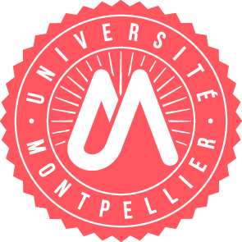
Fiche proposition de stage - Internship offers

Offre pour / Offer for (you can make offers for both level, if the subjects are different, please use a new form) parcours EpiGenBio, qBio or Cancer Biology

✅ Master 2 (from end January)
✅ Master 1 (from end January)

Intitulé du stage  Title | Spatial and temporal regulation of cell division during animal development
Laboratoire d’accueil  Host laboratory | CRBM CNRS UMR5237
Nom du responsable  Name of the PI | Anna CASTRO
Nom d'encadrant  Supervisor | Benjamin LACROIX
Description (3 phrases)  Description (3 sentences) | During cell division, chromosomes are aligned and separated between daughter cells by a macromolecular structure called the mitotic spindle mainly composed by microtubule filaments. We study how these microtubules and the mitotic spindles assemble in various contexts. Within the same animal, different cell types, healthy cells or cancer cells have different spatial organization and temporal constraints. Using high resolution live imaging and in vitro reconstitutions, we aim to investigate the link between cell cycle regulation and perturbation in cancer cells and how they can affect microtubules, spindle assembly and cell division.  Learn more: https://www.youtube.com/watch?v=h5MSjQgo7Xc
Durée prévue (2 à 6 mois)  Duration (2 to 6 months) | up to 6 months
E-mail | benjamin.lacroix@crbm.cnrs.fr

