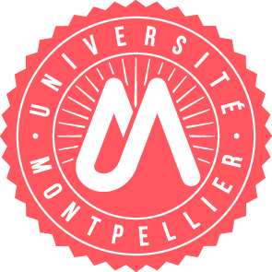
Fiche proposition de stage - Internship offers

Offre pour / Offer for (you can make offers for both level, if the subjects are different, please use a new form)
■ Master 1
■ Master 2

Parcours concerné(s) :
● Cancer Biology

Intitulé du stage  Title | Tackling triple negative breast cancer by targeting vitamin D receptor
Laboratoire d’accueil  Host laboratory | Institut de Recherche en Cancérologie de Montpellier (IRCM)  INSERM U1194  Team “Nuclear Signaling and Cancer”
Nom du responsable  Name of the PI | Vincent CAVAILLES
Nom d'encadrant  Supervisor | Stéphan JALAGUIER
Description (3 phrases)  Description (3 sentences) | Triple negative breast cancers (TNBC) represent 15% of all breast cancers and are characterized by a poor outcome. The vitamin D receptor, shown to be mislocalized in TNBC cells cytoplasm will be targeted in order to reactivate it and thus restore anti-cancer activity. The Master student will benefit from the different technologies of IRCM as well as an international collaboration with a team from Augsburg, Germany.
Durée prevue (2 à 6 mois)  Duration (2 to 6 months) | 5 months
E-mail | stephan.jalaguier@inserm.fr

