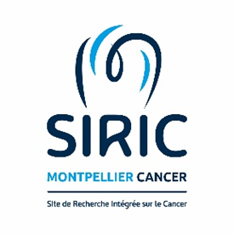

Master program in Cancer Biology
Internship proposal form 2024

MASTER 1

MASTER 2

Title | Encapsulation of MDM2 degraders in polydepsipeptide microparticles for the treatment of liposarcoma.
Host laboratory | Institut de Recherche en Cancérologie de Montpellier (IRCM), INSERM U1194, Team ”Metabolism and sarcoma”
Name of the PI | Laetitia Linares
Supervisors | Julien Pinaud  Benjamin Fourneaux
E-mail- Contact | laetitia.linares@inserm.fr  julien.pinaud@umontpellier.fr  benjamin.fourneaux@inserm.fr
Description (10 lines) | We have recently demonstrated that p53-independent metabolic functions of chromatin-bound MDM2 (C-MDM2) are exacerbated in LPS and mediate an addiction to serine metabolism to sustain nucleotide synthesis and tumor growth. Pharmacological inhibition of C-MDM2 triggering its degradation impaired LPS growth both in vitro and in clinically relevant patient-derived xenograft models. To date, we have developed and validated several C-MDM2 degraders that induce liposarcoma cell death in vitro and in vivo. However, these molecules are poorly soluble and unstable. Although in vivo results in mice are promising, daily treatment is necessary. To address these solubility and stability issues and to achieve efficient long-term delivery of our lead molecules, we aim to develop an innovative, efficient drug delivery strategy by using an encapsulated form of C-MDM2 degraders to achieve prolonged cancer cell accumulation of drugs and enhance treatment efficacy in liposarcoma cancer. The student will aim to optimize the encapsulation of C-MDM2 degraders into the vector, and conduct kinetic drug release. Subsequently the student will assess the efficacy of vectors loaded with C-MDM2 degraders on liposarcoma cell lines. Moreover, she/he will investigate cellular uptake and tumor inhibition efficiency in 3D spheroid model of liposarcoma.
Duration (2 to 6 months) | 6 months

