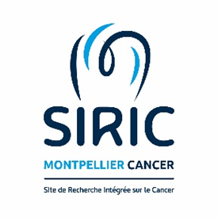

Master program in Cancer Biology
Internship proposal form 2024

☒ MASTER 1
☒ MASTER 2

Title | Overcoming osimertinib resistance in EGFR-driven lung cancer by targeting drug tolerant persister cells
Host laboratory | IRCM
Name of the PI | Antonio MARAVER
Supervisor | David Bracquemond / Maicol Mancini
E-mail- Contact | david.bracquemond@inserm.fr
Description (10 lines) | Patients diagnosed with EGFR-mutated lung adenocarcinoma are treated with specific EGFR inhibitors. Inevitably, almost all patients relapse. A subpopulation of slow-to-non-cycling cells called Drug Tolerant Persisters seems to be responsible for the tumour recurrence.  Our aim is to confirm a link between DTPs and HES1 expression, a transcription factor controlled among others, by the NOTCH pathway, a crucial pathway in lung adenocarcinoma.  Preliminary results showed that combining NOTCH and EGFR inhibition confers a therapeutic benefit as it delays the relapse in vitro and in vivo. Since both treatments seems to strongly impact the cell cycle, we intend to shed light into the exact mechanism of how HES1 levels mediates DTPs status.
Duration (2 to 6 months) | Min 4 months, up to 6.

