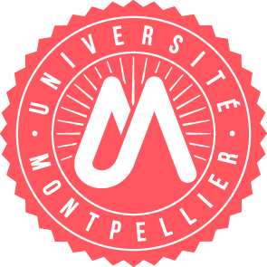
Fiche proposition de stage - Internship offers

Offre pour / Offer for (you can make offers for both level, if the subjects are different, please use a new form)
Master 2

Parcours concerné(s) : CANCER

Intitulé du stage  Title | Deciphering and targeting the collagen-Discoidin Domain Receptor signaling to enhance the therapeutic response in colorectal cancer
Laboratoire d’accueil  Host laboratory | CRBM CNRS UMR5237, “Cancer Cell Signaling” Team
Nom du responsable  Name of the PI | Serge ROCHE
Nom d'encadrant  Supervisor | Audrey SIRVENT
Description (3 phrases)  Description (3 sentences) | Several recent studies suggest that the tyrosine kinase receptors DDR1 and DDR2 are important mediators of collagen-induced tumor-promoting effects, contributing to tumor progression, therapeutic resistance, and poor prognosis in colorectal cancer (CRC). This project aims to: (1) investigate the spatio-temporal dynamics of DDR1/2 signaling using TurboID-based proximity labeling combined to mass spectrometry; (2) characterize the role of DDR1/2 signaling in immune exclusion within the CRC tumor microenvironment and (3) evaluate whether pharmacological inhibition of DDR1/2 kinase activity using already clinically approved drugs developed for other targets can overcome resistance/enhance CRC therapeutic response.  Methods: 2D & 3D cell culture, western-blots, immunoprecipitation, proteomics, multiplex flow cytometry, immunohistochemistry…
Durée prevue (2 à 6 mois)  Duration (2 to 6 months) | 5 to 6 months
E-mail | audrey.sirvent@crbm.cnrs.fr

